Course Section and Title Course Map

Course Objectives
Upon completing this course, the learner will be able to:
CO1: verb followed by the rest of the course objective (no period) ￼
CO2: verb followed by the rest of the course objective (no period)
CO3: verb followed by the rest of the course objective (no period)
CO4: verb followed by the rest of the course objective (no period)
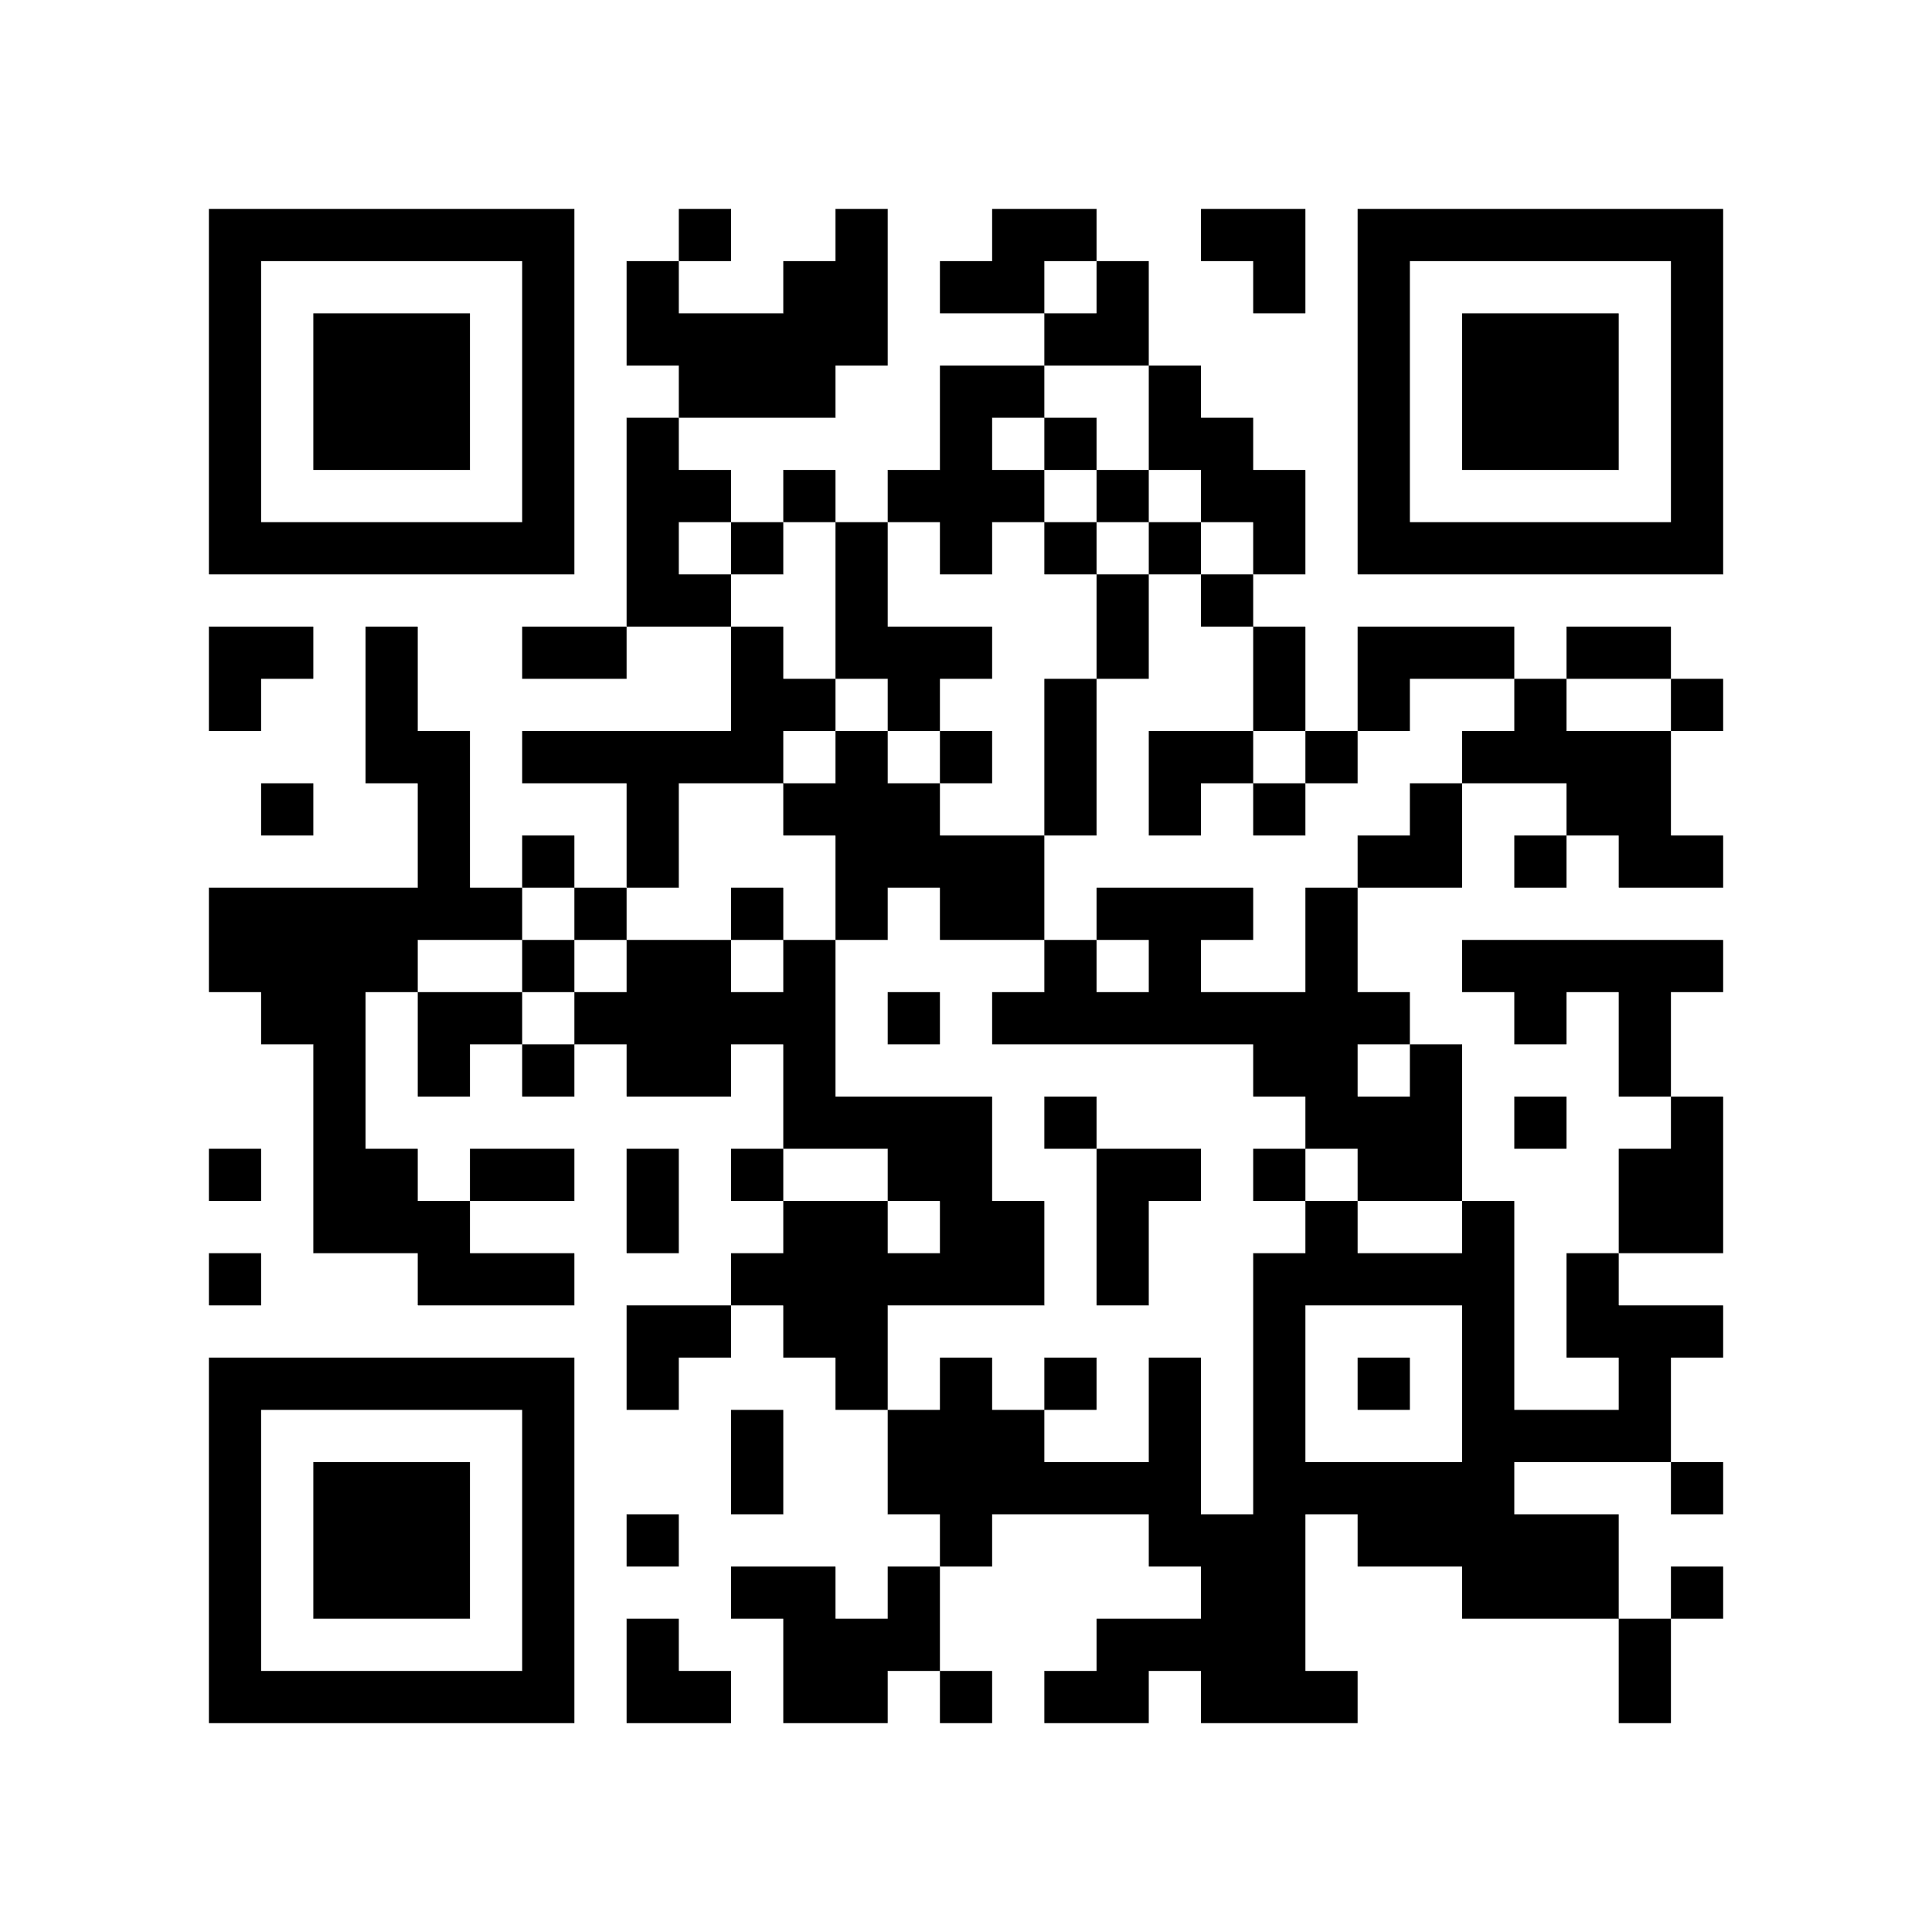
The following table is an excellent example of a completed Module 1 Objectives table. Please reference this example when completing your course map. For more information about the benefits, goals, and how to complete a course map, please scan the QR code or click on the icon to go to our instructional tutorial (4:09).

(EXAMPLE) Module 1 Objective – Learning Objectives
This table shows how materials, activities, and assessments align with the learning objectives.
Course Objective(s) | Module Objective  The learner will be able to: | Instructional Materials  (General Standard 4) | Learning Activities  (General Standard 5) | Assessments  (General Standard 3)
CLO1: Develop measurable module learning objectives | MLO1.1: Recognize the levels of Bloom’s Taxonomy  MLO1.2: Identify the measurability of learning objectives | HTML Content Page discusses Bloom's Taxonomy and measurable learning objectives.  Bloom’s Taxonomy video. | Creator+ Practice (Sequencing: Bloom's Taxonomy Levels)  Creator+ Practice  (Multi-Select: measurable learning objectives) | Learning Objectives Quiz (T/F, MC, & MS questions)
CLO1: Develop measurable module learning objectives | MLO1.4: Apply Bloom’s to a Module Learning Objective | HTML Content Page & Bloom’s Taxonomy video. |  | Learning Objectives assignment submission

Module 1 Objectives – Module Title
This table shows how materials, activities, and assessments align with the learning objectives.
Course Objective(s) | Module Objective  The learner will be able to: | Instructional Materials  (General Standard 4) | Learning Activities  (General Standard 5) | Assessments  (General Standard 3)

Module 2 Objectives – Module Title
This table shows how materials, activities, and assessments align with the learning objectives.
Course Objective(s) | Module Objective  The learner will be able to: | Instructional Materials  (General Standard 4) | Learning Activities  (General Standard 5) | Assessments  (General Standard 3)

Module 3 Objectives – Module Title
This table shows how materials, activities, and assessments align with the learning objectives.
Course Objective(s) | Module Objective  The learner will be able to: | Instructional Materials  (General Standard 4) | Learning Activities  (General Standard 5) | Assessments  (General Standard 3)

Module 4 Objectives – Module Title
This table shows how materials, activities, and assessments align with the learning objectives.
Course Objective(s) | Module Objective  The learner will be able to: | Instructional Materials  (General Standard 4) | Learning Activities  (General Standard 5) | Assessments  (General Standard 3)

Module 5 Objectives – Module Title
This table shows how materials, activities, and assessments align with the learning objectives.
Course Objective(s) | Module Objective  The learner will be able to: | Instructional Materials  (General Standard 4) | Learning Activities  (General Standard 5) | Assessments  (General Standard 3)

Module 6 Objectives – Module Title
This table shows how materials, activities, and assessments align with the learning objectives.
Course Objective(s) | Module Objective  The learner will be able to: | Instructional Materials  (General Standard 4) | Learning Activities  (General Standard 5) | Assessments  (General Standard 3)

Module 7 Objectives – Module Title
This table shows how materials, activities, and assessments align with the learning objectives.
Course Objective(s) | Module Objective  The learner will be able to: | Instructional Materials  (General Standard 4) | Learning Activities  (General Standard 5) | Assessments  (General Standard 3)

Module 8 Objectives – Module Title
This table shows how materials, activities, and assessments align with the learning objectives.
Course Objective(s) | Module Objective  The learner will be able to: | Instructional Materials  (General Standard 4) | Learning Activities  (General Standard 5) | Assessments  (General Standard 3)

